N+ Network Security
Firewall NAT Port Filtering Packet filtering

1. Set up Windows Defender Firewall on your Windows laptop or PC and create a new inbound rule to block all incoming traffic on port 8080. Take a screenshot of the rule you created.
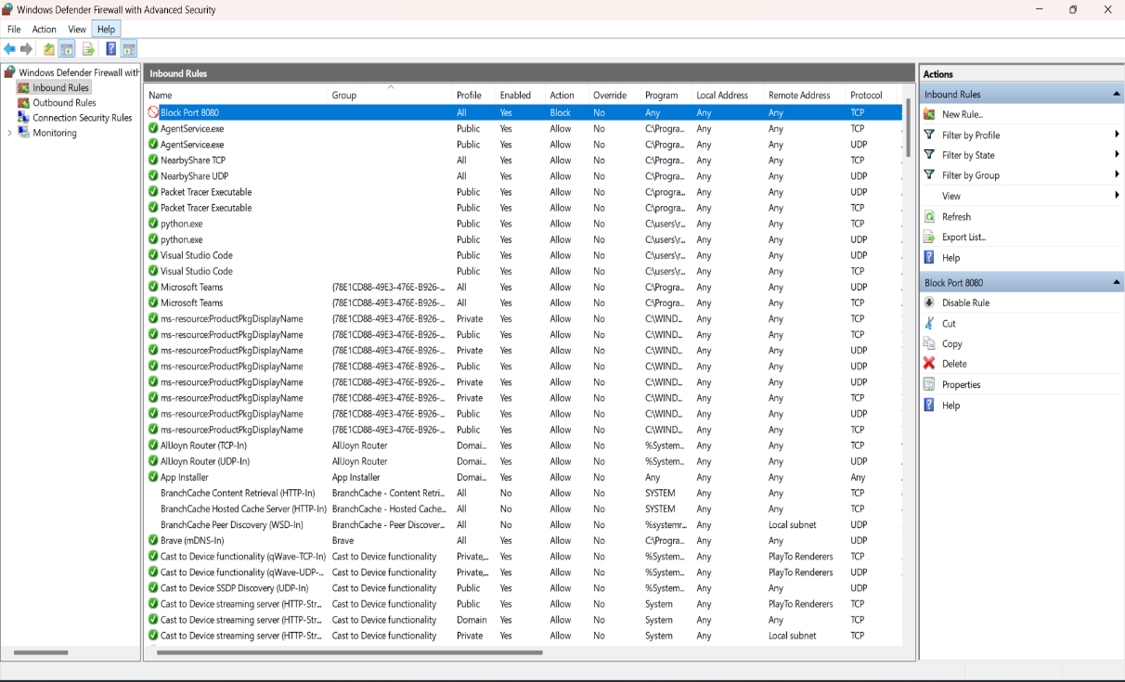
2. Simulate NAT (Network Address Translation) by drawing a simple diagram showing how your home WiFi router assigns private IP addresses to your phone, laptop, and smart TV, and how it translates them to a single public IP for internet access.<br><br><em><strong>Hint:</strong> Use any drawing tool or even hand-draw and click a photo.</em>
=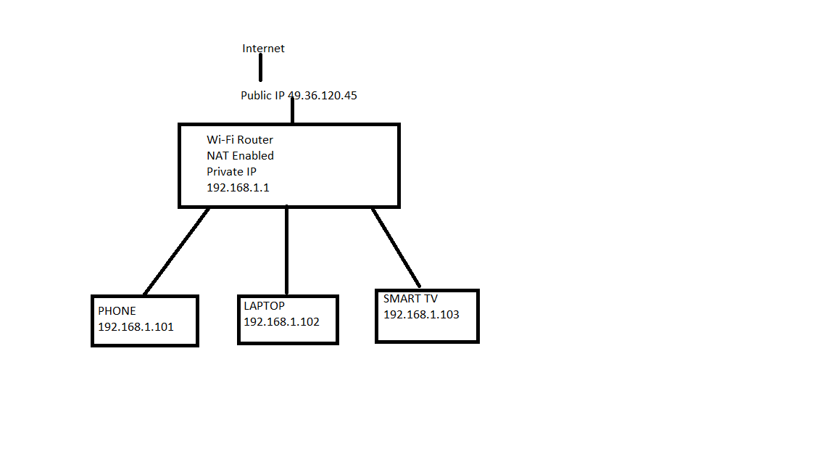
3. Configure port filtering using your WiFi router's admin panel (or use a router simulator online if you don't have access). Block outgoing traffic on port 25 (SMTP) and explain in 2 sentences how this could help prevent spam from your network.
= Steps to Configure Port Filtering (Block Outgoing Port 25)
- Log in to your Wi-Fi router's admin panel (e.g., 192.168.1.1).
- Go to Security, Firewall, or Access Control (name varies by router).
- Open Port Filtering or Outbound Rules.
- Create a new rule:
  - Direction: Outbound
  - Protocol: TCP
  - Port: 25
  - Action: Block/Deny
- Save the rule and apply the changes. Restart the router if required.
Explanation (2 sentences):
Blocking outgoing traffic on port 25 (SMTP) helps prevent infected devices from sending spam emails directly to mail servers. This reduces the risk of your network being used for spam or email-based malware attacks.
4. Given a sample packet filtering rule set (provided by your trainer), identify which of these three sample packets would be allowed or blocked: 1) HTTP request from 192.168.1.5 to 172.217.166.78:80, 2) SSH request from 10.0.0.10 to 34.201.23.1:22, 3) DNS query from 192.168.1.7 to 8.8.8.8:53.<br><br><em><strong>Hint:</strong> Focus on source/destination IPs and ports in the rule set.</em>.
= The result depends on the packet filtering rule set provided by your trainer. Without those rules, it isn't possible to determine whether each packet is allowed or blocked.
Here's the packet summary:
Packet | Source IP | Destination IP | Destination Port | Protocol | Result
1 | 192.168.1.5 | 172.217.166.78 | 80 | HTTP | Depends on rule set
2 | 10.0.0.10 | 34.201.23.1 | 22 | SSH | Depends on rule set
3 | 192.168.1.7 | 8.8.8.8 | 53 | DNS | Depends on rule set
5. Research and list 3 ways Instagram or Zomato might use firewalls and packet filtering to protect their servers from attacks or misuse.
= How Instagram or Zomato Use Firewalls and Packet Filtering
- Block Unauthorized Access
  - Firewalls allow only approved ports (such as HTTPS on port 443) and block unwanted traffic to protect servers.
- Prevent DDoS Attacks
  - Packet filtering detects and blocks suspicious or excessive traffic from malicious IP addresses, helping keep the service available.
- Filter Malicious Requests
  - Firewalls inspect incoming requests and block harmful traffic, such as hacking attempts, malware, or SQL injection attacks, before they reach the application.
These firewall and packet-filtering techniques help protect user accounts, maintain service availability, and improve the overall security of platforms like Instagram and Zomato.

